Yukyong Choe

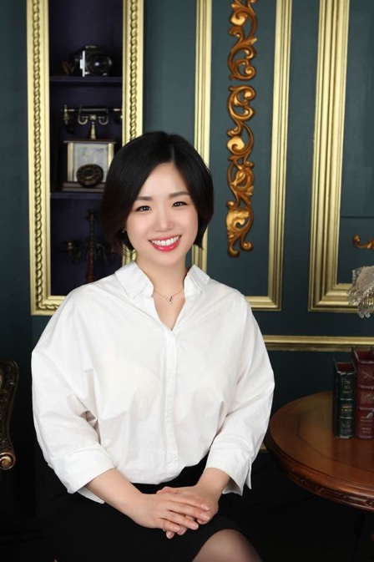
Yukyong Choe is a Research Fellow at Korea Legislation Research Institute (KLRI), a government-funded research institute specializing in legislation and policy making in the Republic of Korea. She received her LL.M. & JSD degrees from the UC BerkeleyLaw. Before she went to Berkeley, she got her Master in International Law and was a Ph.D. candidate at Seoul National University after getting her B.A. in Law from Ewha Womans University.

Yukyong was invited as a visiting scholar at the Center for the Study of Law and Society (CSLS) at UC Berkeley from 2011 to 2013 when she expanded her research on recent legal reform to inter-Asian countries, including Japan, China and Taiwan. She served as a founding-fellow of the Judicial Policy Research Institute (JPRI) established under the Supreme Court of Korea since 2014. She also worked for the Ewha Institute for Biomedical Law and Ethics in 2015.

Since 2013, she has been teaching constitutional law, law & society, modern legal system & jurisprudence in diverse schools nationwide, including Seoul National University, Yonsei University and Ewha Womans Law School, etc. She has deepest interest in Globalization of the Korean Law that she has enriched academic relationships with the Korea Law Center at UC Berkeley and Center for the Korean Legal Studies at Columbia Law School by holding international conferences focusing on the Constitutional Changes issues & the Rule of Law in peacemaking in East Asia. She has been enthusiastically participated in ALSA since 2010, trying to reaching out her academic networks through Asia and worldwide. Her most recent publications are titled, “Ex-Post Legislative Evaluation on the Retail Business Development Act” (KLRI, 2017) and “Evaluation on the Korean Refugee Act of 2013 and Legal Approaches for Future Revision”(Ministry of Justice, 2016). “Who Watches the Watchmen: A Disciplinary System for Lawyers in Korea on Empirical Approaches” are forthcoming in 2018.

