Matthew S. Erie

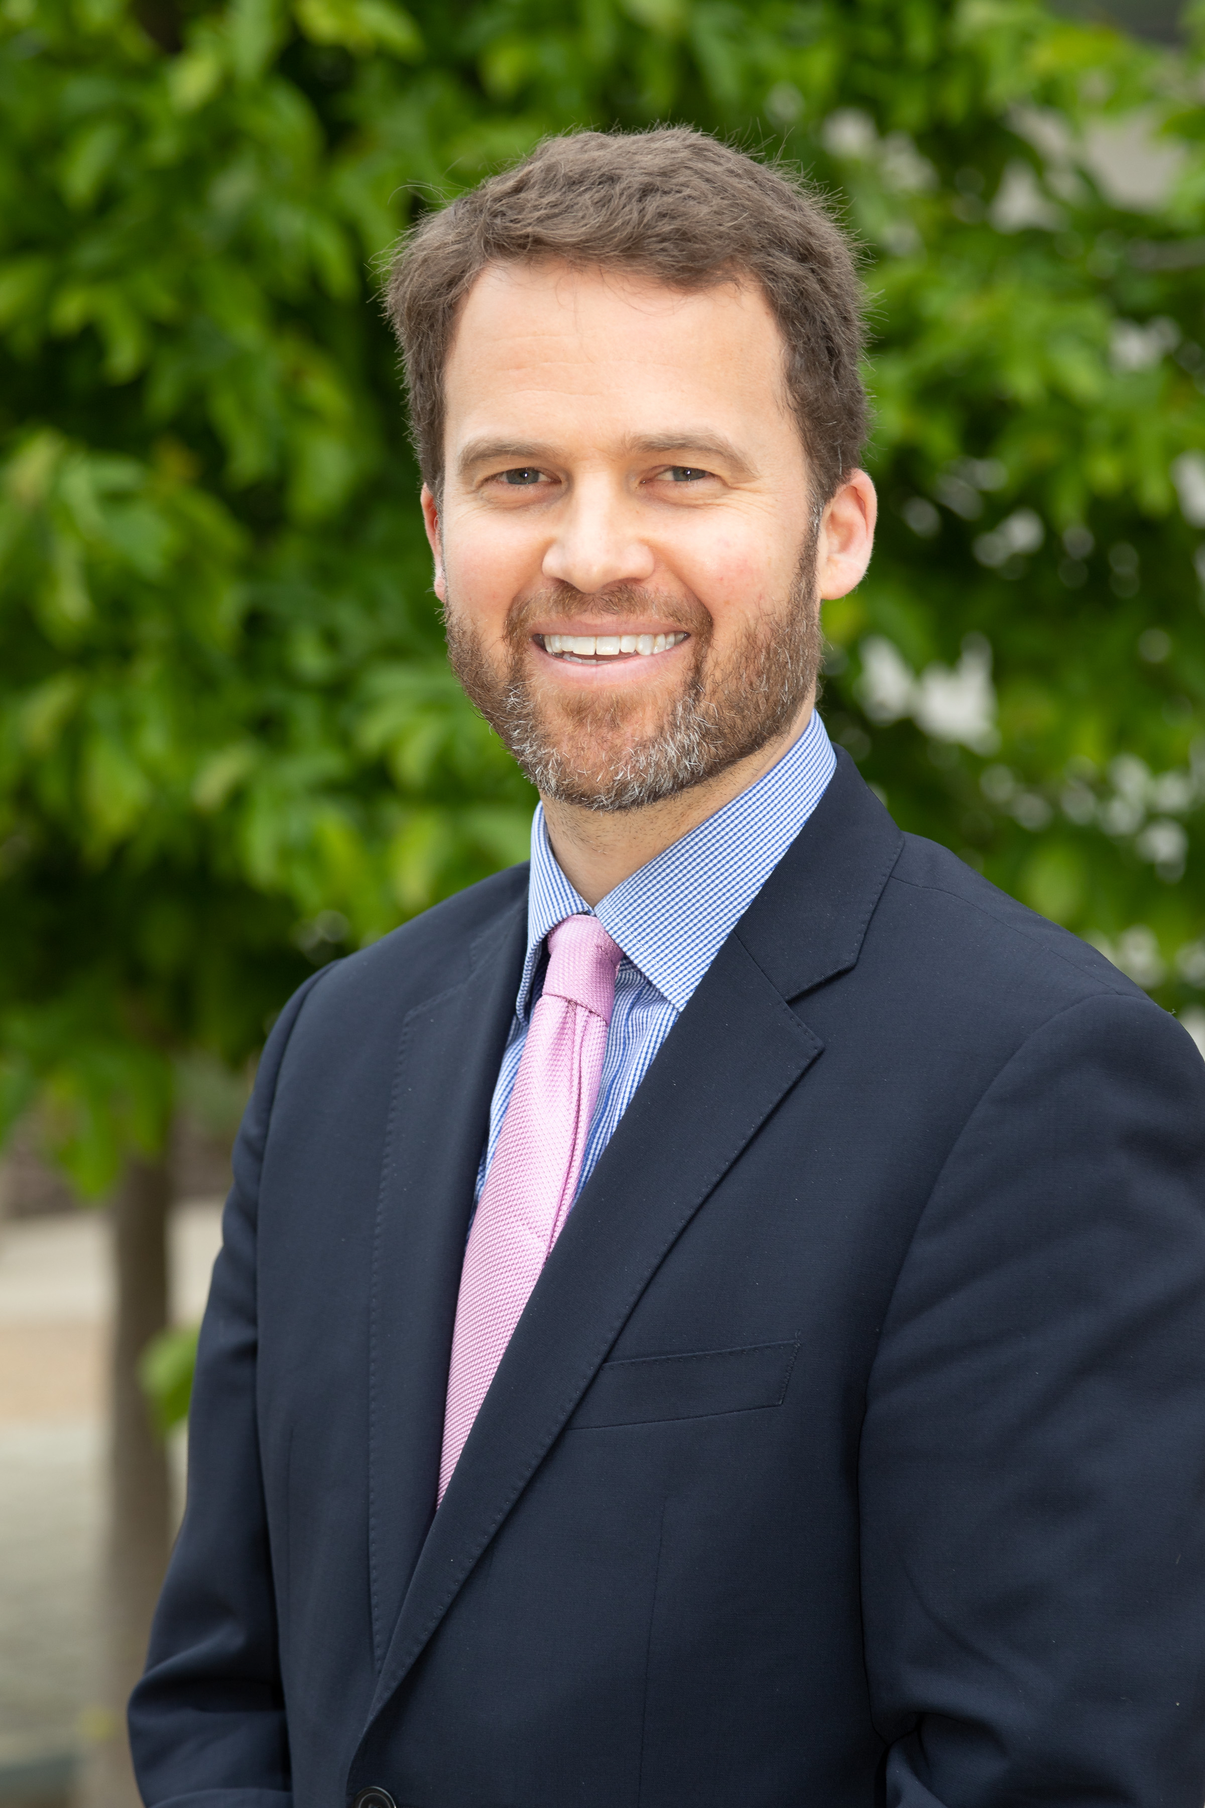
Matthew S. Erie (J.D., Ph.D.) is an Associate Professor of Modern Chinese Studies and Associate Research Fellow of the Socio-Legal Studies Centre at the University of Oxford. Professor Erie’s interdisciplinary work stimulates conversations between law and anthropology. In particular, he investigates the emergence and reconciliation of conflicts of law and normative pluralism in the course of increasing intersections of non-liberal values and Anglo-American common law. His current research, funded by a European Research Council Starting Grant, examines the impact of Chinese outbound capital on international economic law and the legal development of host states, many of them weak and fragile economies. Professor Erie previously held academic positions at Princeton University and NYU Law School, and he was a visiting scholar at the National University Singapore Law Faculty. In the fall 2018, he is a Global Research Fellow in the Hauser Global Program of NYU Law School. He practiced law in the New York and Beijing offices of Paul Hastings LLP. He holds degrees from Cornell University (Ph.D., Anthropology), University of Pennsylvania (J.D.), Tsinghua University Law School (LL.M.), and Dartmouth College (B.A). Professor Erie is a member of the New York Bar, the American Society of International Law, the National Committee on U.S.-China Relations, and the Law and Society Association.

