Mari HIRAYAMA

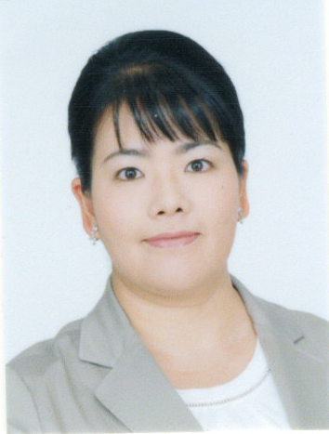Mari HIRAYAMA is Professor of Criminal Procedure & Criminology at Hakuoh University, Tochigi, Japan. She holds Master of Laws from Kwansei Gakuin University. She also holds LL.M. from University of Minnesota Law School (on the Fulbright Program). She has conducted research on lay participation in criminal justice system, especially issues in sex crime cases tried by the Lay Judge Trials. Recently she is also conducting research on videotaped interrogations and their status as evidence at criminal trials. Her recent publications are; “A Future Prospect of Criminal Justice Policy for Sex Crime in Japan-the Roles of the Lay Judge System There” in Jianhong Liu and Setsuo Miyazawa (eds.), Crime and Justice in Contemporary Japan (Springer 2018) pp303-317, with Others『法システム入門―法社会学的アプローチ―（第4版）』［Introduction to the Justice System- Approach of Sociology of Law - 4th Edition］(in Japanese)(Shinzansya Publication 2018), “Introduction of Videotaping of Interrogations and the Lessons of the Imaichi Case: A Case of Conventional Criminal Justice Policy-Making in Japan” (with Setsuo Miyazawa), Washington International Law Review, Vol. 27 No. 1 (2017), pp.148-176.

