Chulwoo Lee

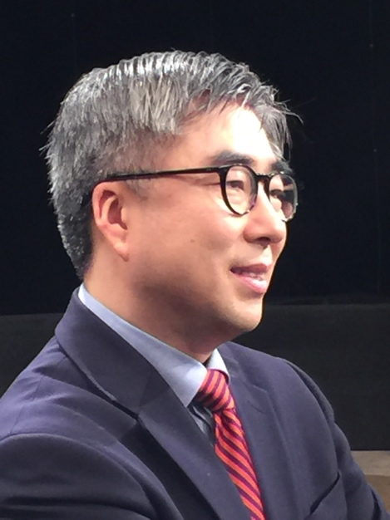
Chulwoo Lee is Professor of Law at Yonsei Law School. He studied at Seoul National University (LL.B. and LL.M.), Georgetown University Law Center (LL.M.), and the London School of Economics and Political Science (Ph.D.). He held full-time faculty positions at the Hankuk University of Foreign Studies and Sungkyunkwan University, and taught at the University of Washington School of Law as Garvey Schubert Barer Visiting Professor of Asian Law (2011). His areas of academic interest include law and social theory, social history of law, and citizenship and nationhood. Among his publications are “Hegemony, Contestation, and Empowerment: The Politics of Law and Society Studies in South Korea” (Asian Journal of Law and Society, 2014), “How Can You Say You’re Korean? Law, Governmentality and National Membership in South Korea” (Citizenship Studies, 2012), and the book Immigration Law (2016, corresponding author with nine co-authors). Chulwoo Lee was President of the Korean Law and Society Association and has been a member of the Board of Trustees of the Asian Law and Society Association. At Yonsei, he worked as Director of the Institute of Legal Studies until August 2018.

