Eri Osaka

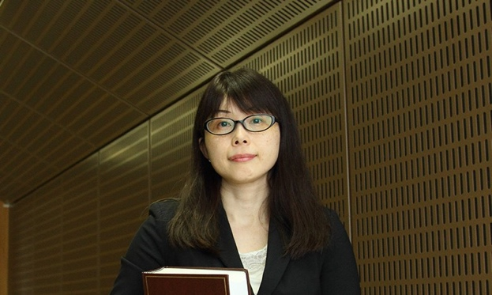
Eri Osaka is a Professor of Law at Toyo University, Tokyo, Japan, where she teaches Environmental Law and Civil Law. She is a 2000 graduate from Penn Law LLM program under the Fulbright Graduate Student Program, and also holds a BA and an MA in Law from Waseda University, Japan. She joined the University of Pennsylvania Law School SJD program in 2015. Her research interests lie in the legal response to mass toxic torts and mass disaster torts. Since the Fukushima Nuclear Accident, she has been studying the legal issues on victim compensation and recovery. She co-edited “Law and Policy of the Recovery from the Damage Caused by the Nuclear Accident” (Nippon Hyoron Sha, 2018) (in Japanese). She has served as a trustee of the Asian Law and Society Association, a board member of the Japanese Association of Sociology of Law, an editor of the Research on Environmental Disruption (Japan Environmental Council), an editor of the Journal of Environmental Law and Policy (Japan Association for Environmental Law and Policy) and so on.

